TEAM NAME: TECHIE

TEAM NUMBER:21

BHAVESH VEERAMACHANENI

TEJASWINI PULIVARTHI

BRAHMANI KANIKANTI

MONICA NADAKUDITI

**FITNESS DIARY**

**PROJECT GOAL AND OBJECTIVES**:

**MOTIVATION:**

we believe that best way to lose weight is simply to keep track of foods we take in. Without a proper diet and tracking we think we waste a lot of time and energy simply having unhealthy food and later stressing to reduce the consequences of it. So we would like to design an app that make calorie counting and food tracking easy so we could track the health and weight anywhere anytime. This would give you a brief description of what to and what not to until you attain your goal.

**UNIQUENESS:**

We focus on making sure that users can log their meals as quickly and as easily as possible. Our idea is, the easier we make it for users the more likely they are to stay on track and the more likely they are to succeed in their weight loss goals.

We will create a place where the user either want to increase the weight or to decrease the weight. We want to show them how many calories have been taken and show suggestions accordingly so that they can either increase or decrease the weight. We create a home page where users must set their goal and what they have taken in. The app searches for the calorie count automatically and we also provide a custom calorie count option where the user enters the calorie of unknown food. We also provide a feature where it takes input as ingredients and gives output as what food is best keeping goal in mind. It will automatically generate a book or diary of your daily events so that you can track your changes.

**OBJECTIVES:**

Loose or gain the weight in a healthy manner by keeping track of food we eat and activities we do and finding nutritional values for the food we take. Getting low calorie or high protein or high nutritional recipes with the ingredients left in our home.

**SYSTEM FEATURE**S:

* Food Search
* Calorie counter
* Food tracking
* Recipes for Left off ingredients
* Nutrition Pie chart
* Exercise search
* Goals and their progress

**HOW FAR WE HAVE COME:**

* We have created a login and register page for user.
* Recipe search has been implemented which contains the process, ingredients and calorie of the recipe. Additional feature that has been added is searching a recipe with left over ingredients.
* Food tracking that is calorie of the food consumed for breakfast, lunch, snacks, dinner and total calorie consumed for a day is tracked.
* Fitness tracking has been implemented with activities cycling, walking, running, gym workouts.
* Gym search has been implemented.

**WHAT’S NEXT:**

* Graphs for calorie consumed, calorie burned and calories needed to be consumed or burned need to be produced for daily, weekly, monthly and yearly basis.
* Database integration for whole project needed to be done.
* Google sign in and facebook sign in to be provided.
* Notes log to be provided.
* Can have a little UI upgrade.

**SERVICES DESCRIPTION**:

* **Recipe Search**: This API consists of over 1.5 million recipes with detailed nutrition for each recipe. Also, filters by calories, diets and allergens.

[https://api.edamam.com/search?app_id=${APP_ID)&app_key=${APP_KEY}](https://api.edamam.com/search?app_id=$%7bAPP_ID)&app_key=$%7bAPP_KEY%7d)

* **Recipe Analysis** : This API analyses nutrition for entire recipes-recipe title, ingredient list and instructions included.

<https://api.edamam.com/api/nutrition-details>

* **Food Database**: This API returns nutritional information for the specified ingredient.

<https://api.edamam.com/api/nutrition-data>

**GitHub URL:**

<https://github.com/Tejaswini94/ASE_PROJECT/wiki/Increment-1>

**Architecture Diagram:**

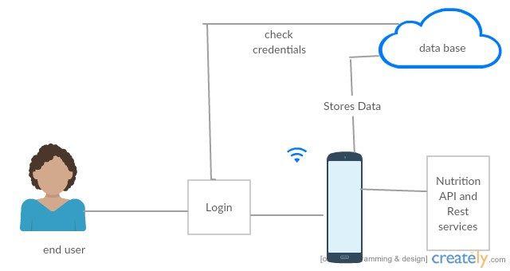

**Class Diagram:**

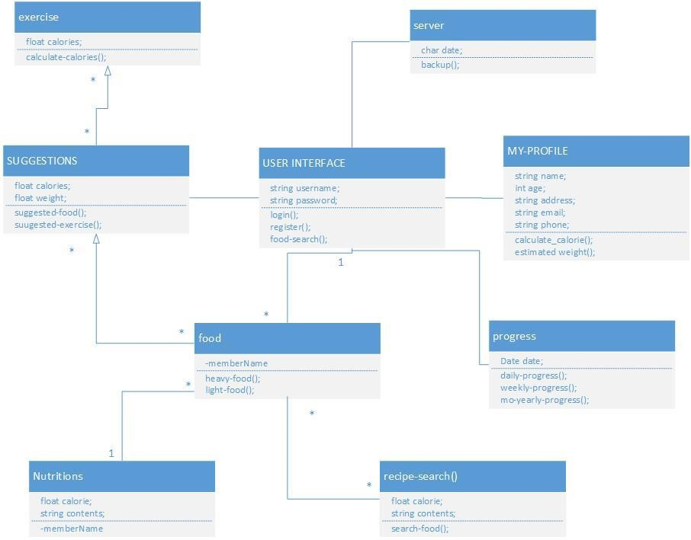

**Sequence Daigram:**

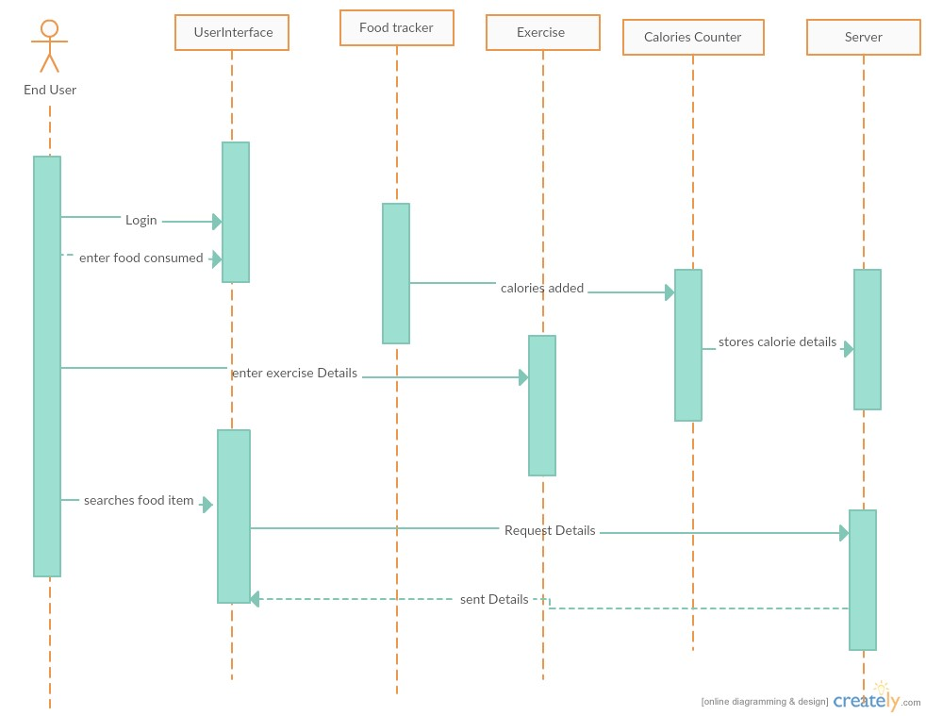

**Issue Tool Bar:**

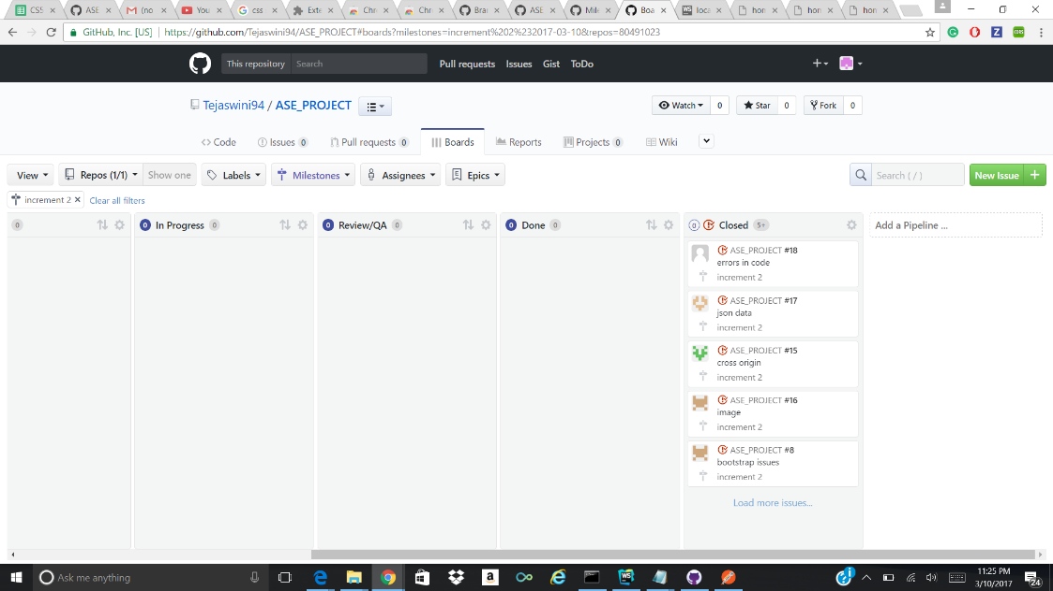

Tasks are assigned to each of us and we made a regular update of the assigned task Also Milestone has been created.

**Burn Down Graph:**

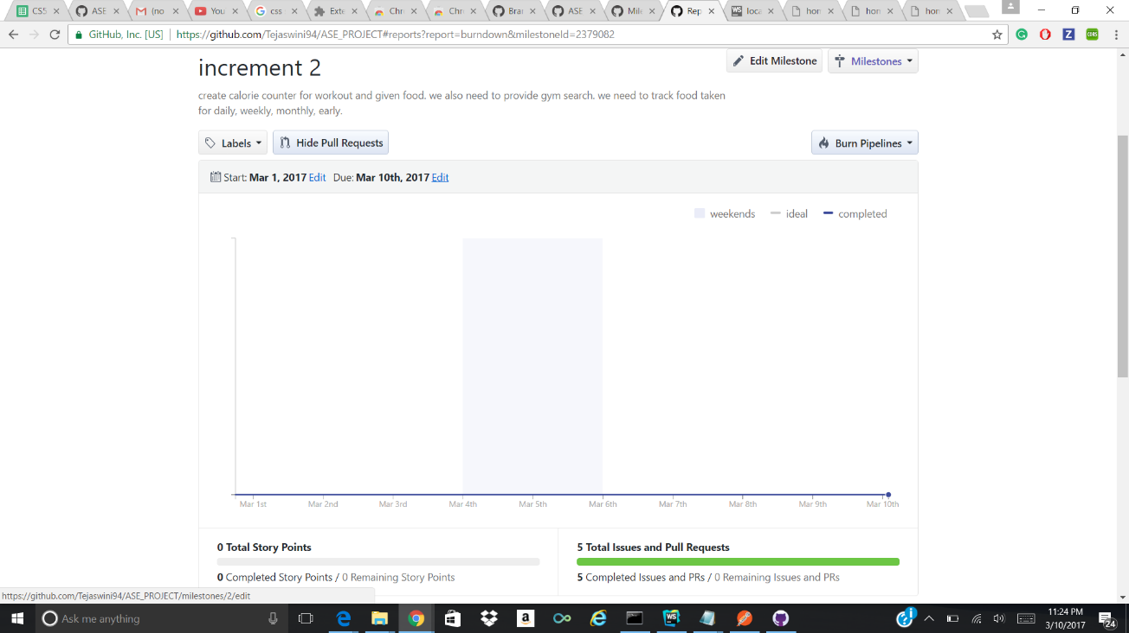

Burn down chart for assigned and completed task is shown above. Milestone for first increment was set to March 10.

**Wire Frames:**

**Login Page:**

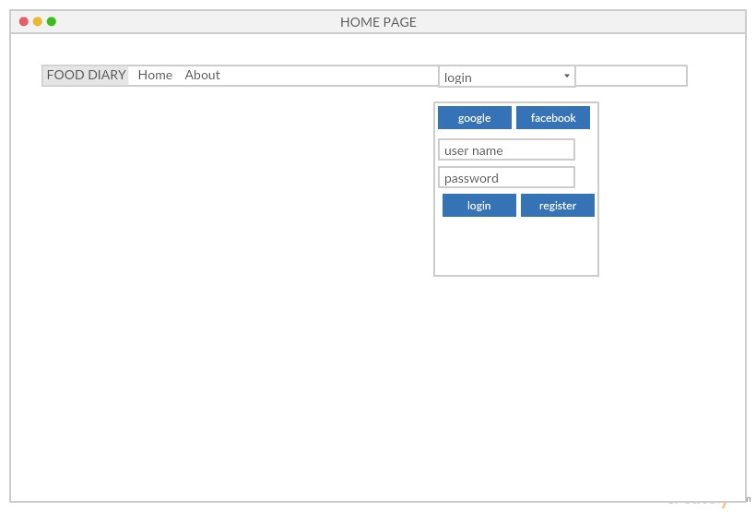

**Register Page:**

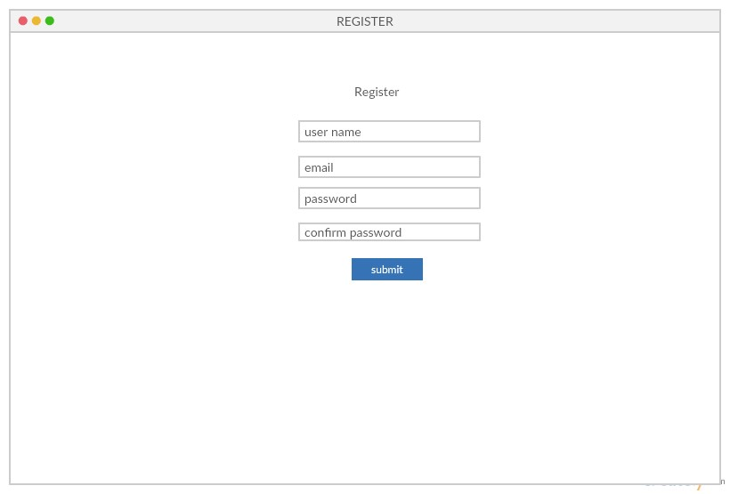

**Dashboard:**

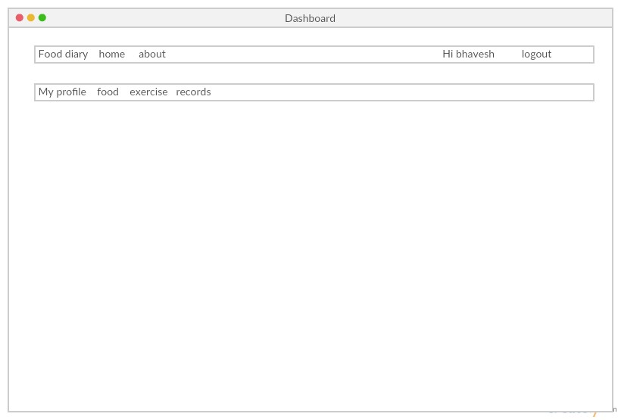

**Calorie Calculator for Gym Workouts:**

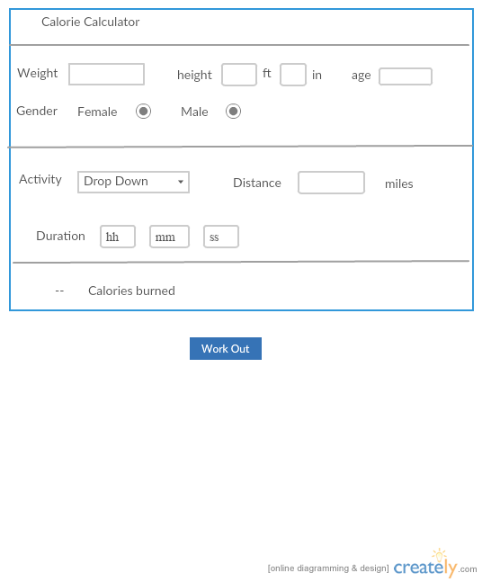

**Daily Calorie Intake:**

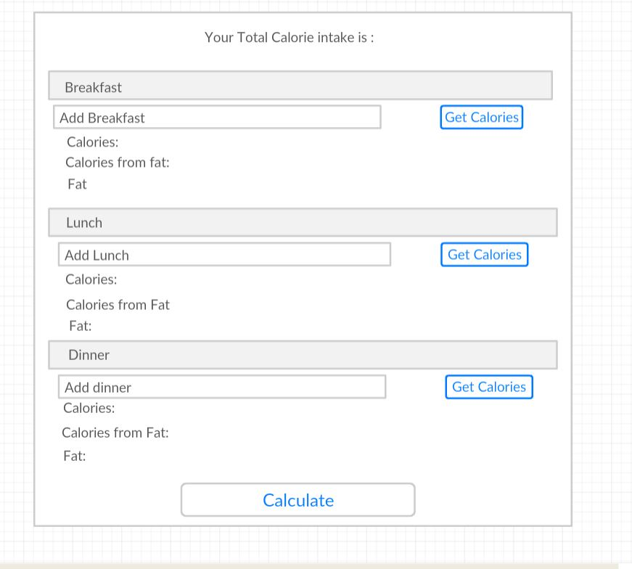

**Food Search:**

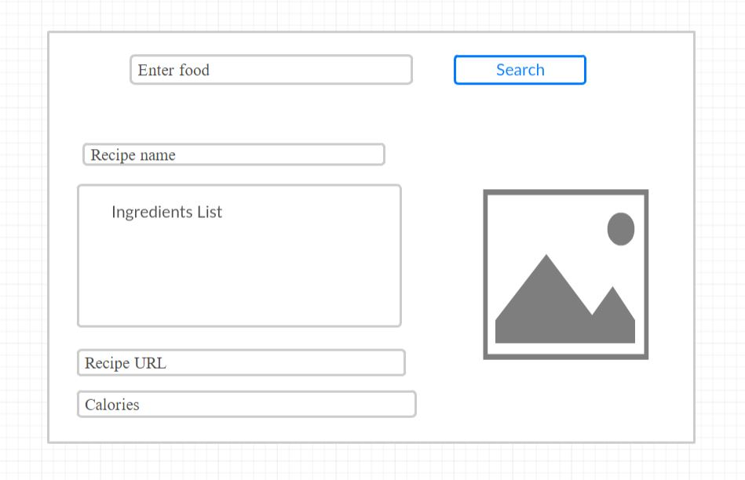

**Mock ups:**



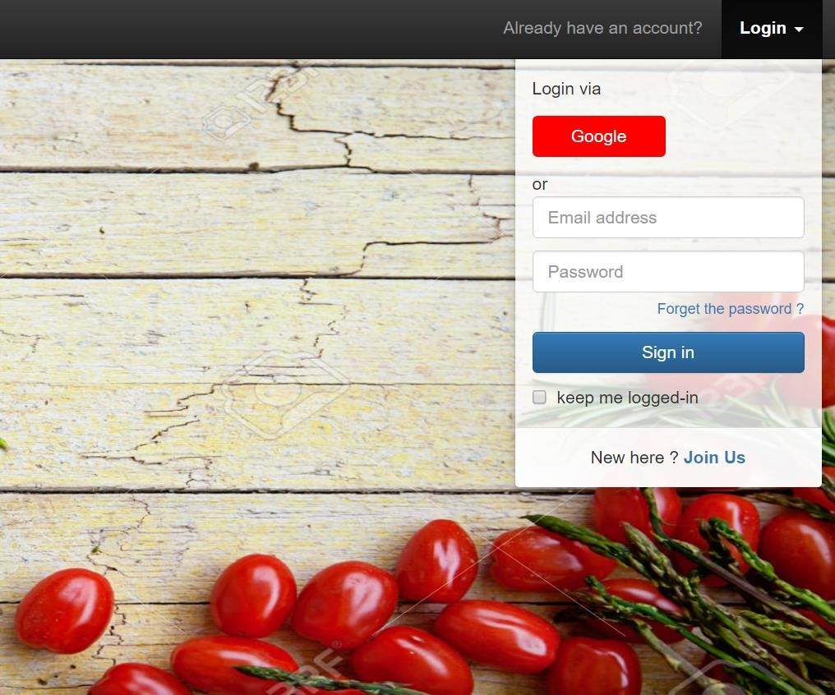

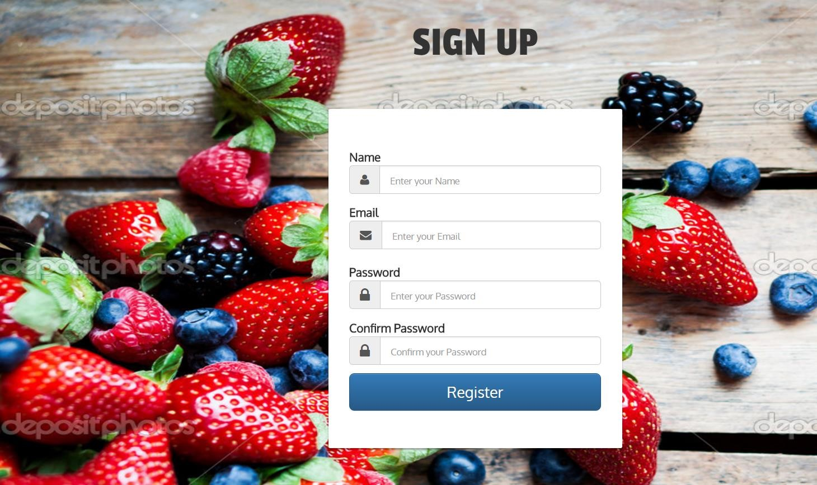

**Gym Finder:**

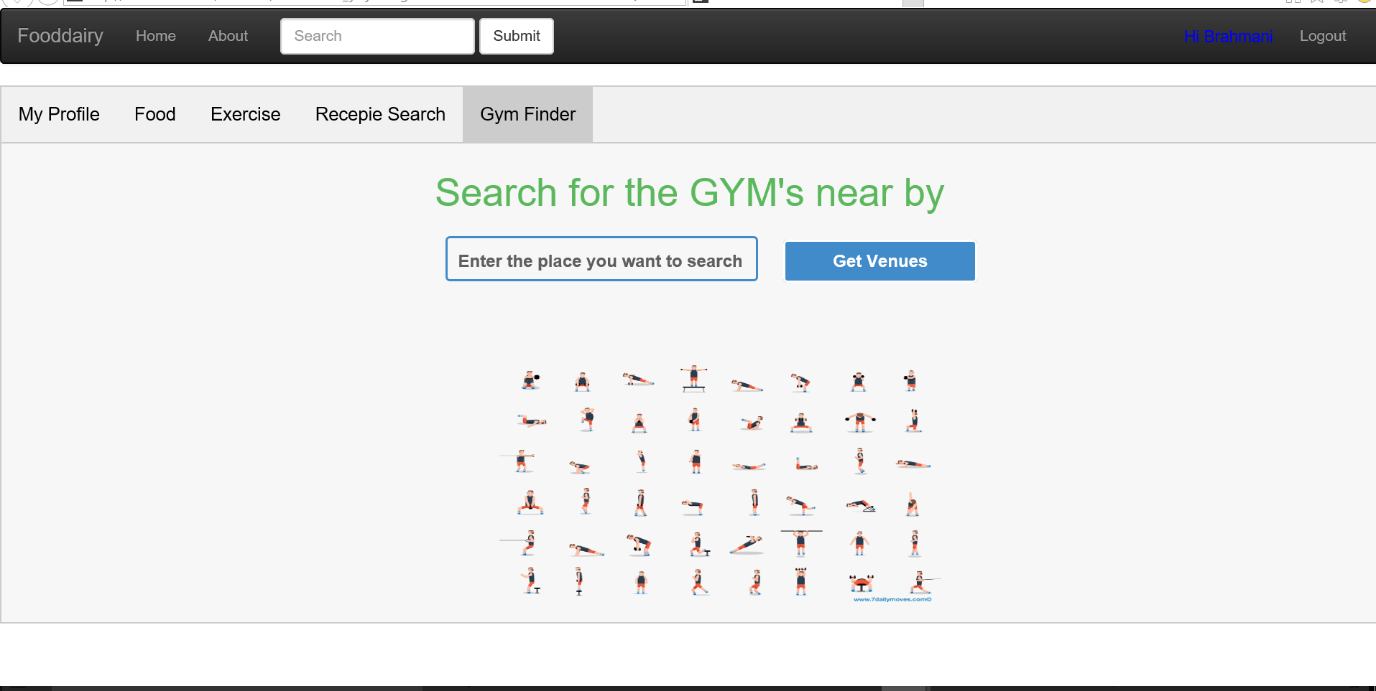

**Food:**

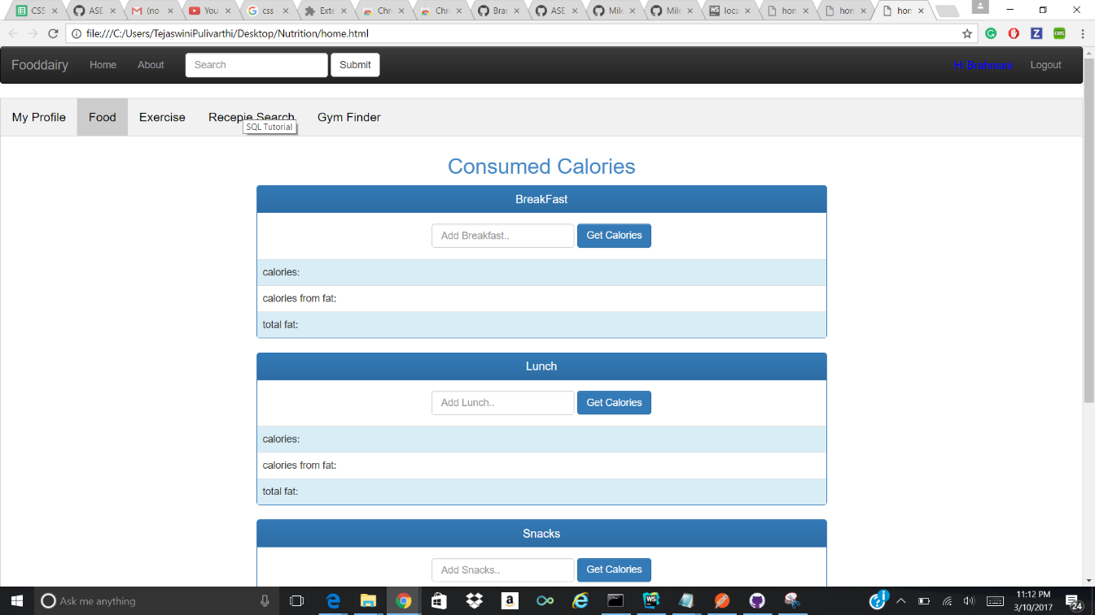

**Exercise:**

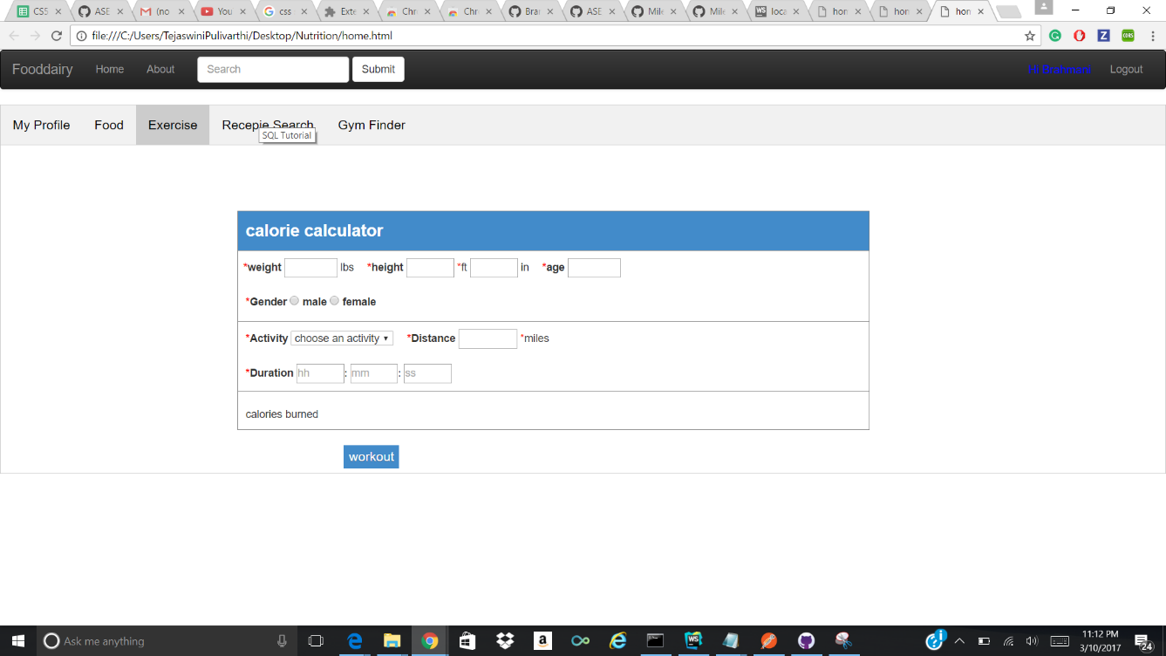

**Recipe Search:**

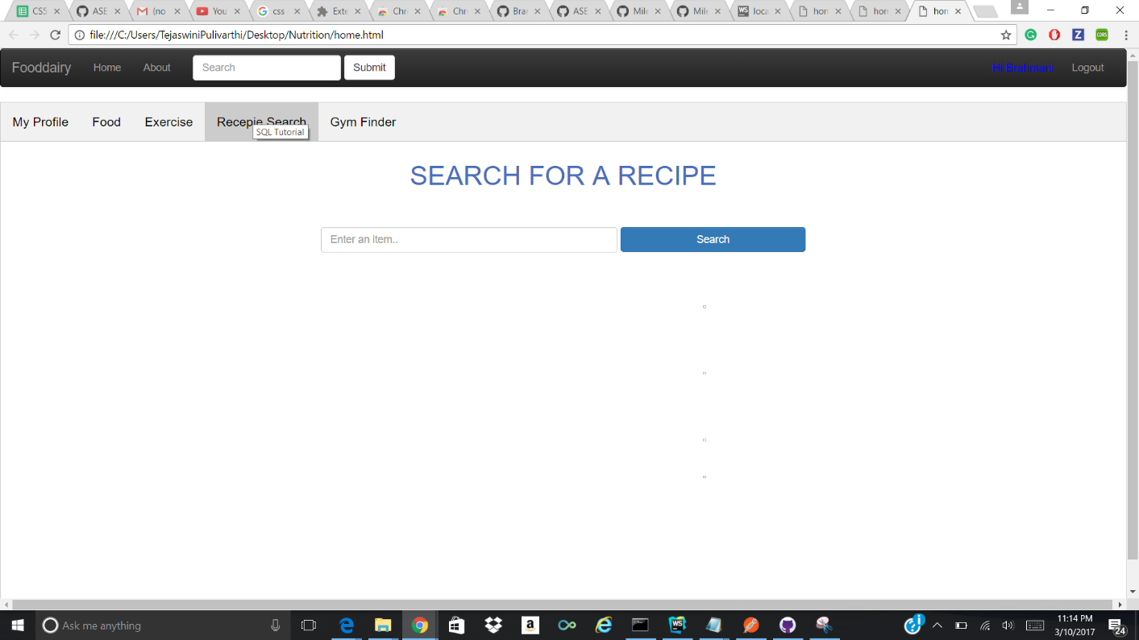

**User Stories:**

|  |  |  |
| --- | --- | --- |
| **As a** | **I want to** | **So that,** |
| User | Signup account | I can register in FoodDiary app |
| Login as user | I can access the app |
| Set my goal | I can gain, reduce or balance my weight |
| Maintain diary | I can keep track of my daily intake |
| Search for new recipes and their corresponding nutritional values | I can achieve my goal |
| Use calorie counter | I can exercise and eat accordingly |
| Maintain record | I can review my progress |

**Use Case:**

* **Recipe Search**: User searches the recipes based on the available ingredients. He can also filter based on calories, diets and allergens. .
* **Calorie Counter**: Based on the user's goal, FoodDiary displays the intake of calories per day. Also, calculates the count based on the calories burnt and gained.
* **Nutritional Values**: User can also obtain the overall nutritional values of a recipe, ingredient based on the serving.
* **Dairy**: User maintains a record of the food intake per each day along with exercises done.
* **Report**: FoodDiary keeps track of the progress of the user based on his goal.

**Test cases:**

|  |  |  |  |
| --- | --- | --- | --- |
| **TEST CASE NAME** | **TEST**  **DESCRIPTION** | **EXPECTED RESULTS** | **PASS/FAIL** |
| Sign Up | Enter email id without @ | Asks to display valid email id | Pass |
|  | Enter valid details | Navigates to login  page | Pass |
| Login | Enter invalid user id and invalid password | Invalid login error message displays | Pass |
|  | Enter valid user id and password | Navigates to home page | Pass |
|  | Enter invalid user id and valid password | Invalid login error message displays | Pass |
| Logout | Press the logout button | Navigates to the login page | Pass |

**Final Screen Shots:**

**Login**

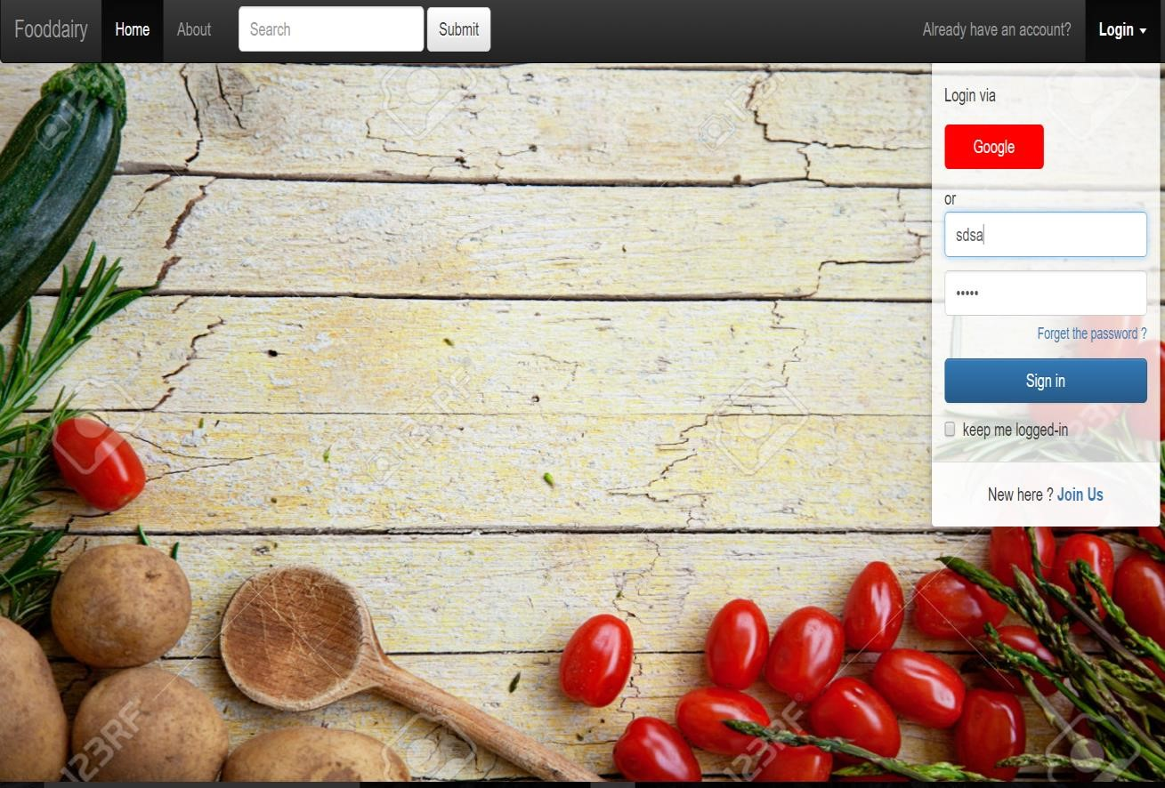

**Registration Page:**



**Sign up with validation:**

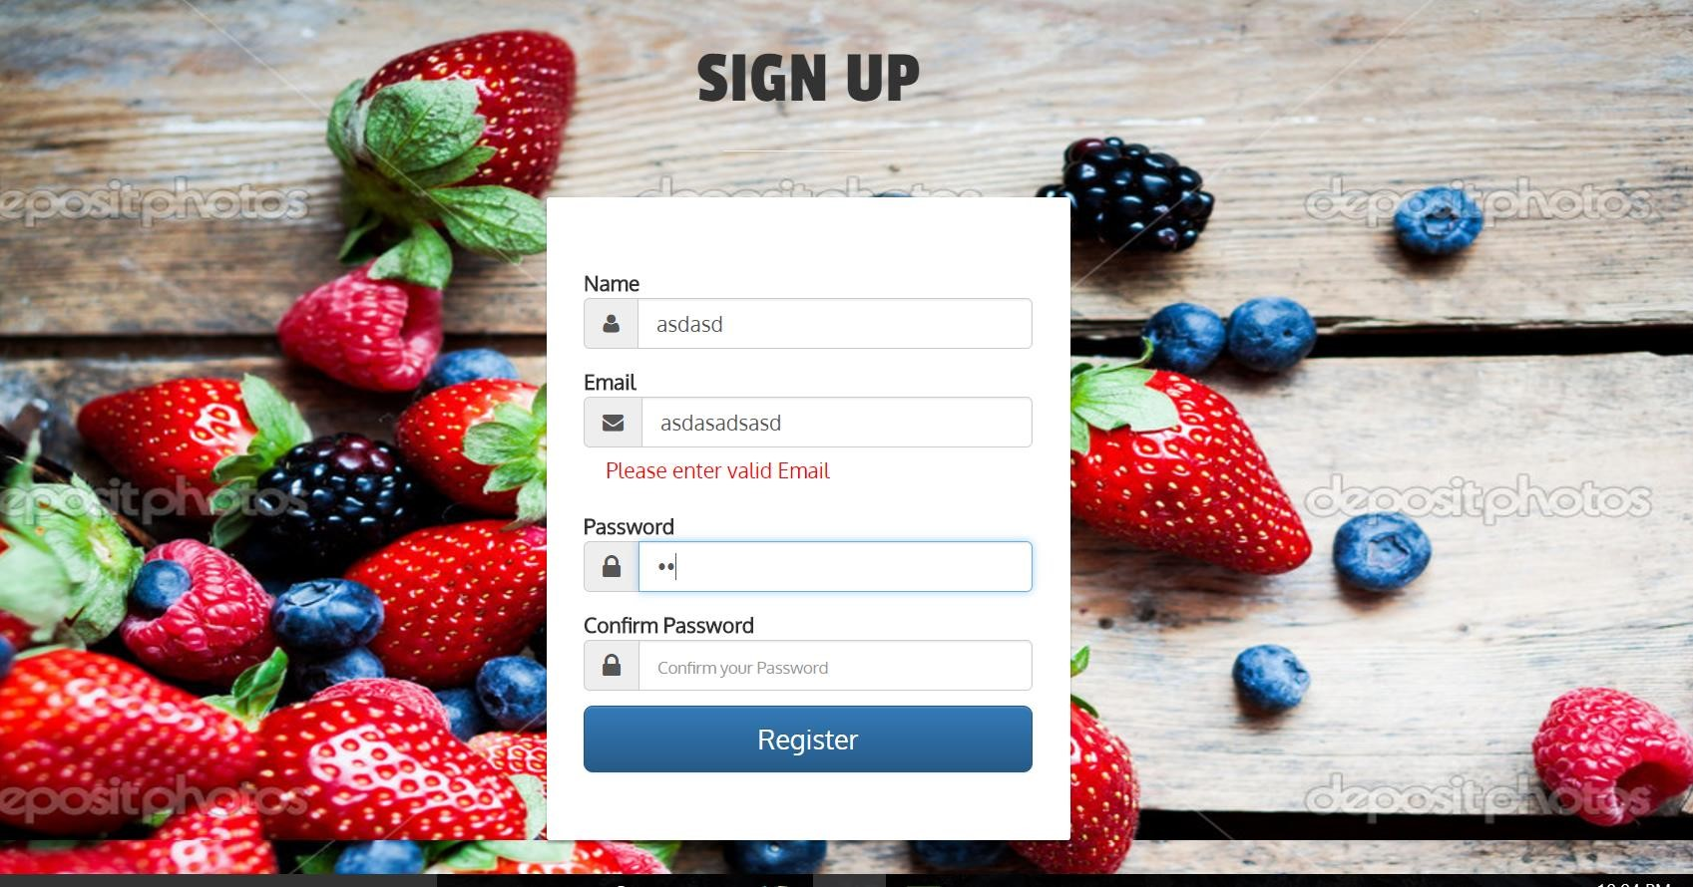

**Dashboard:**

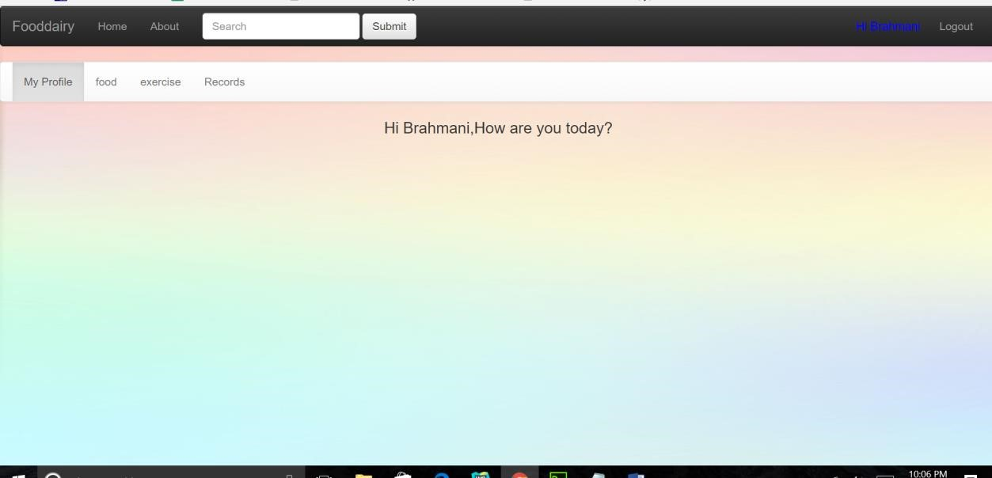

Food:

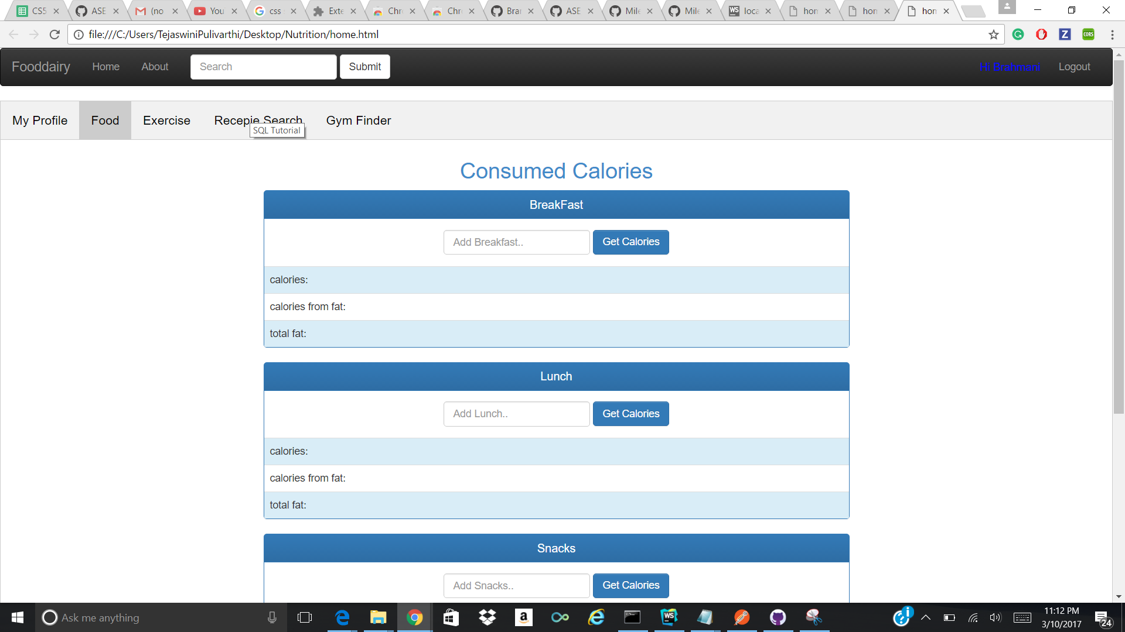

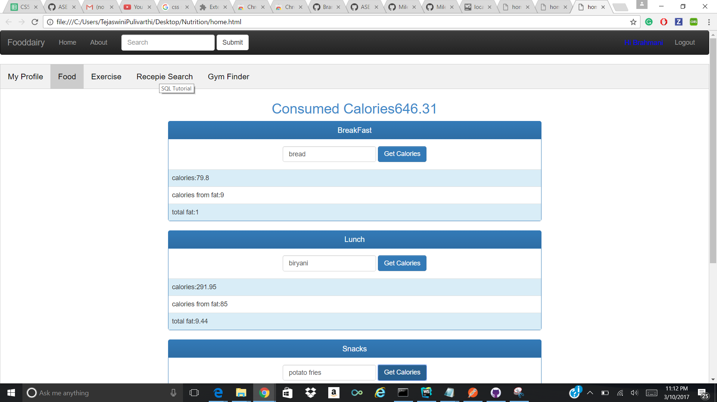

Exercise:

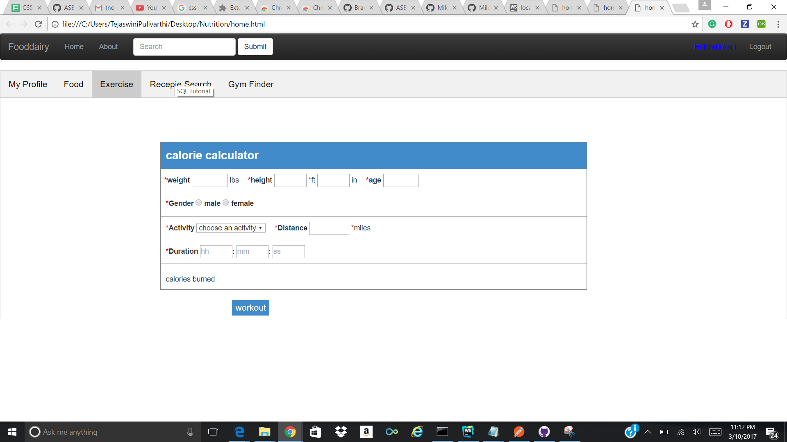

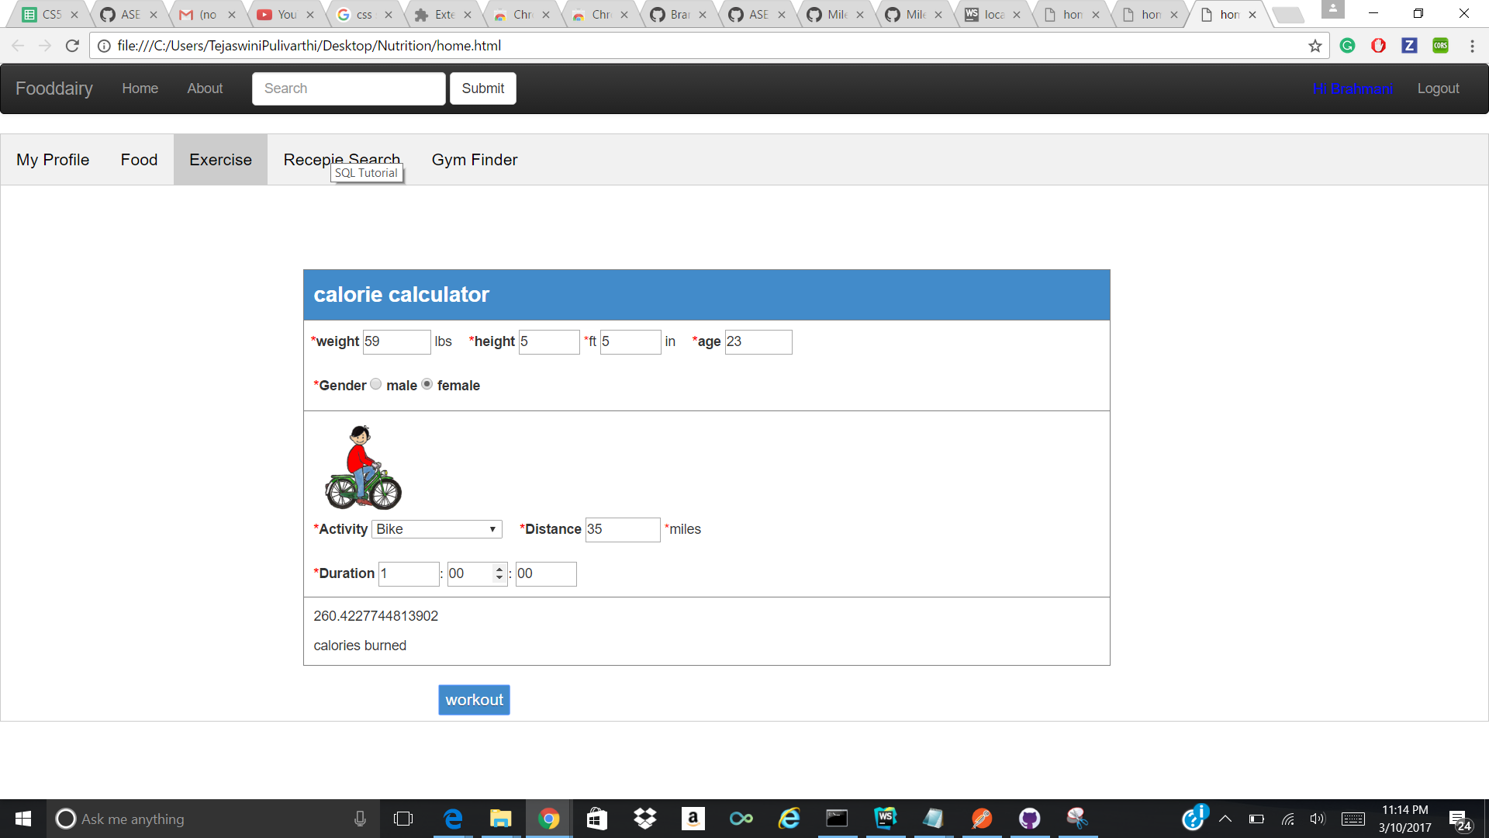

Recipe Search:

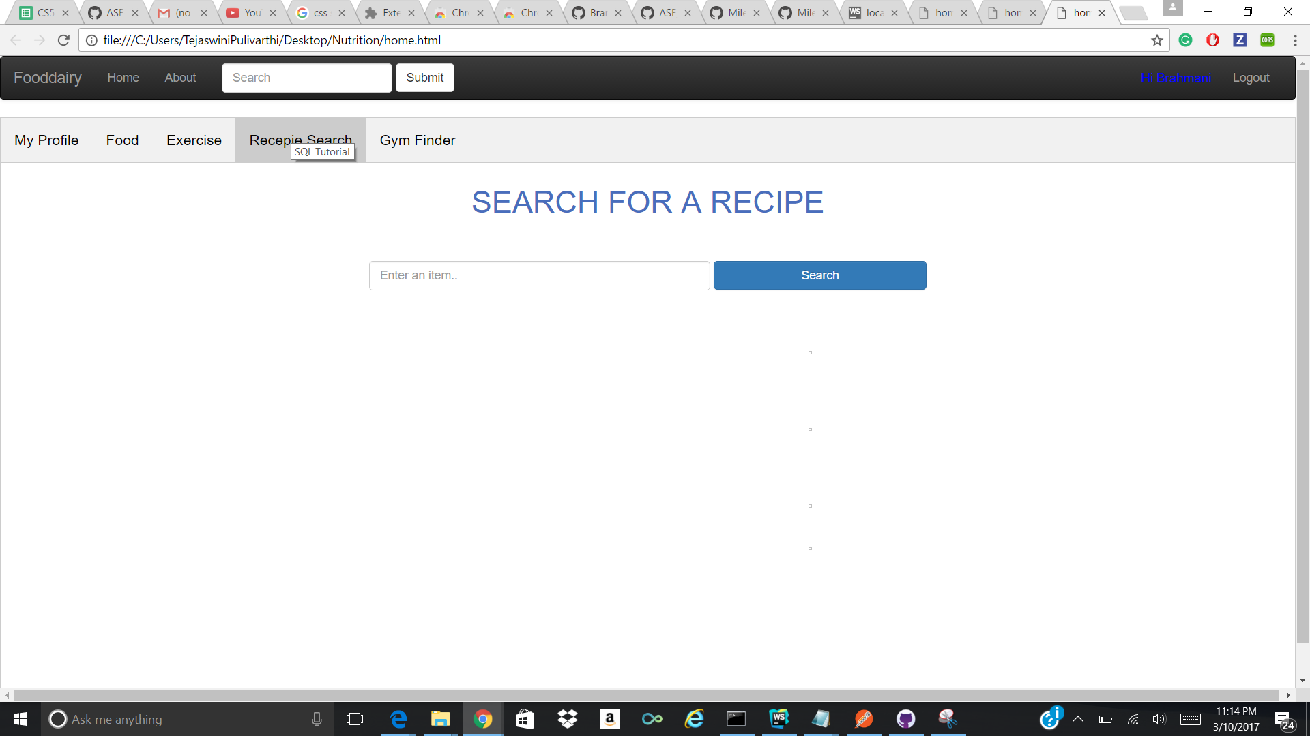

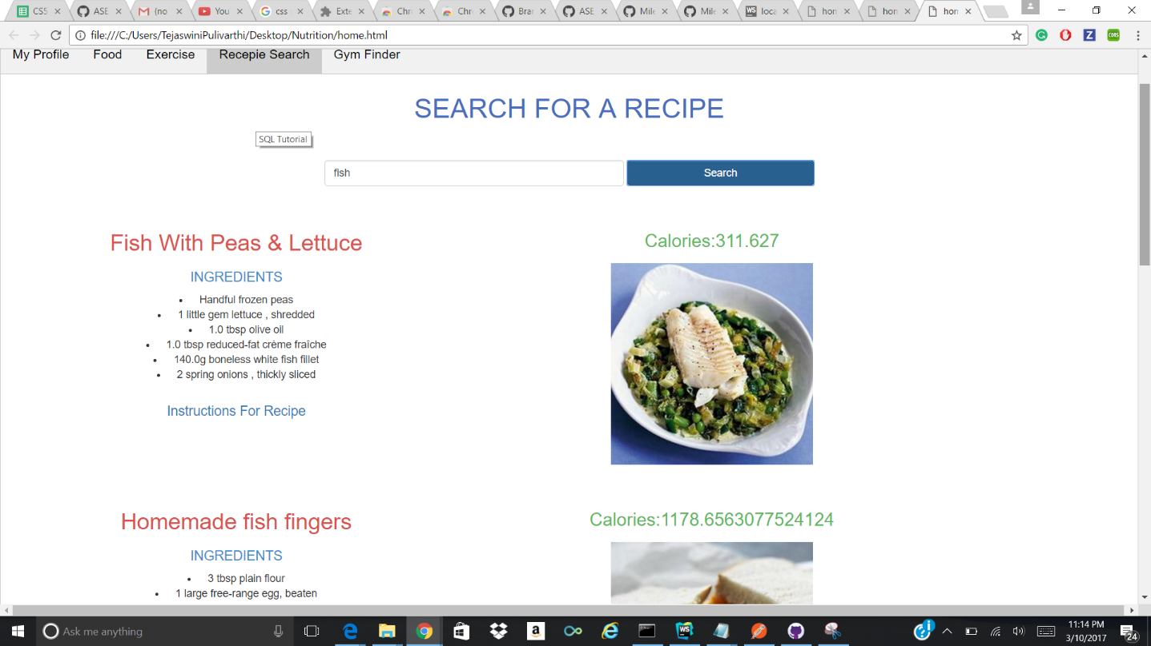

Gym Finder:

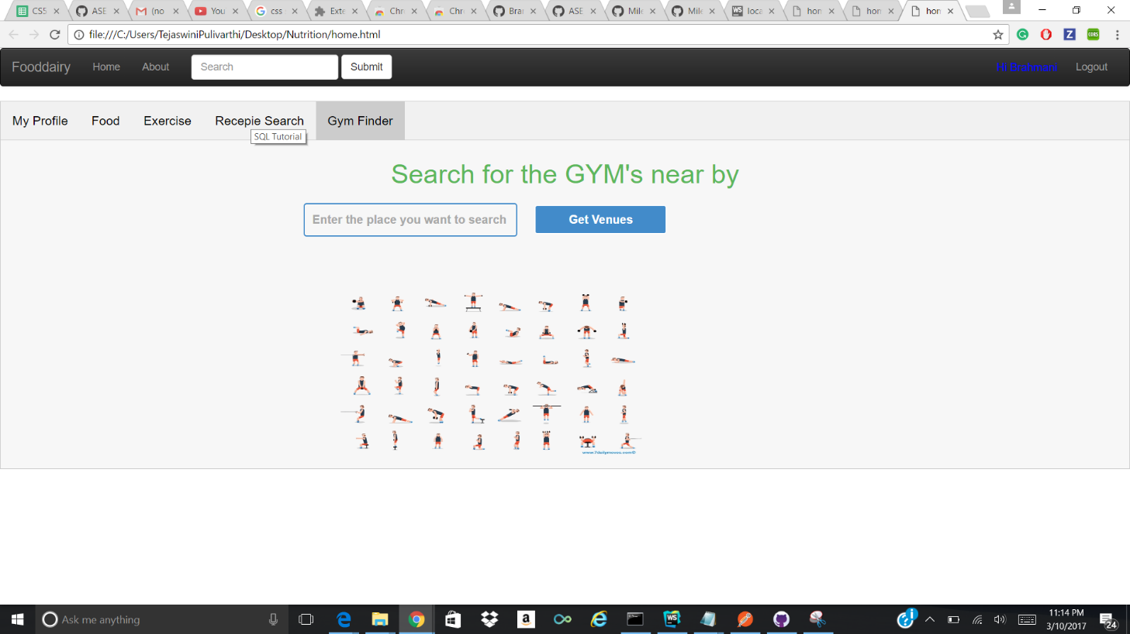

Created Database using Mongodb for Signup Page:

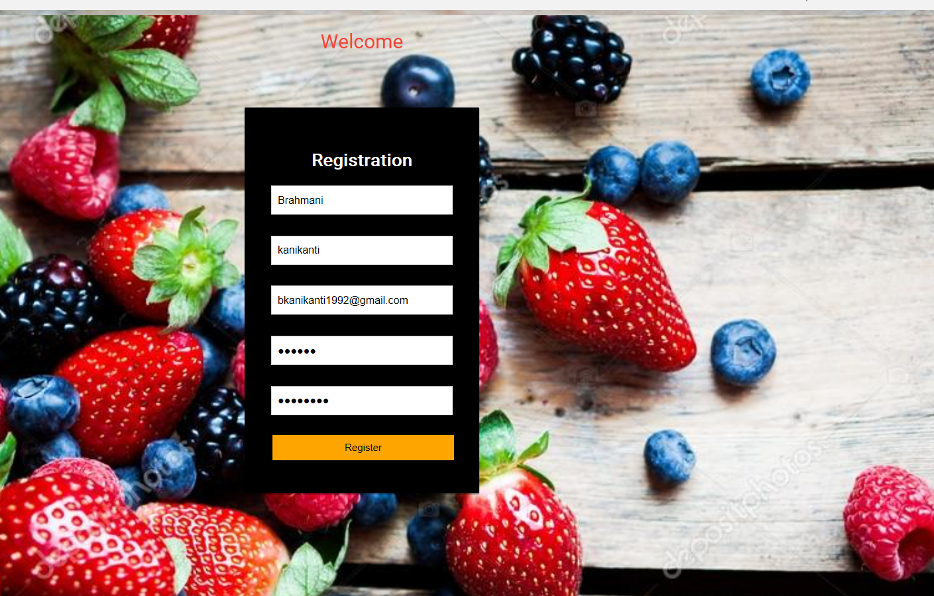

Created collections for storing users data

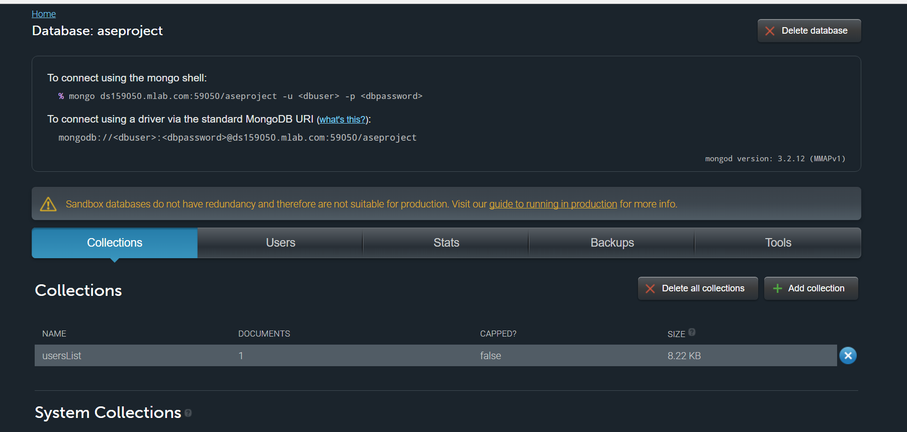

Checked whether the users data is stored or not.

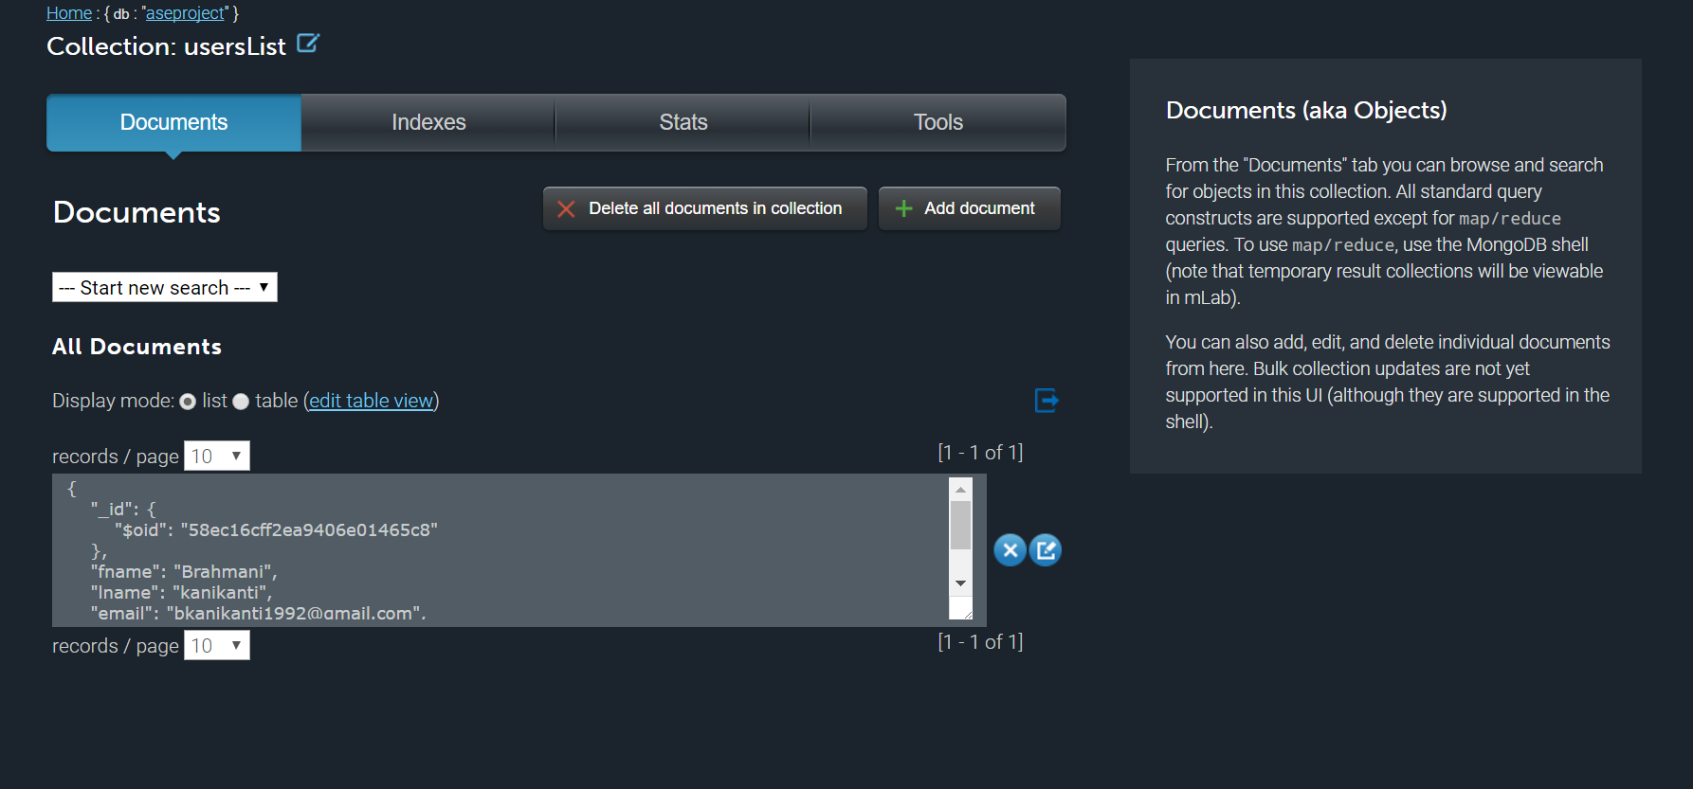

Popup Graph

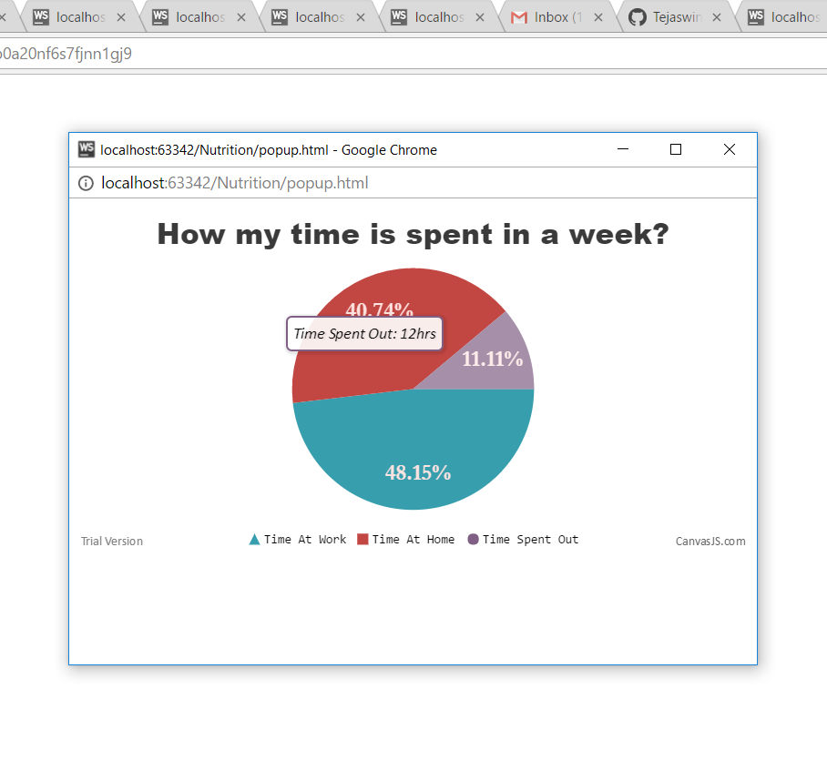

**Performed Unit Testing:**

Unit Testing is a level of software testing where individual components are tested. This is done to validate that each unit of software performs as designed.